Got health and social transfers pretty wrong at the end of 2018:

Federal social transfers (excluding health)

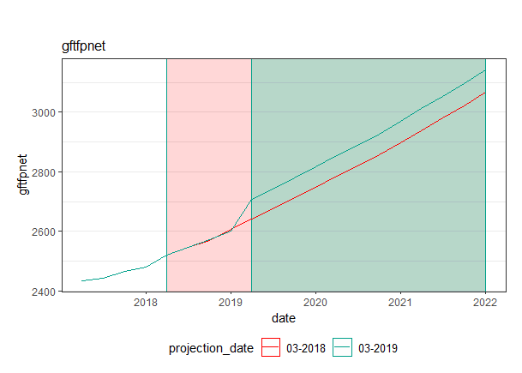

Medicare

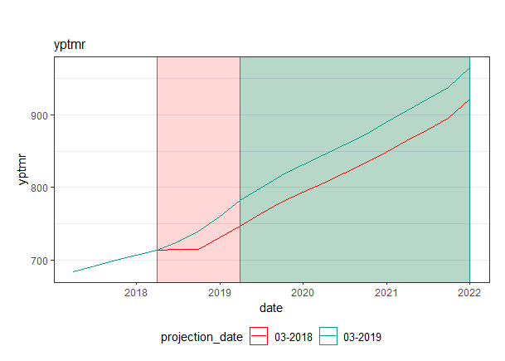

Medicaid

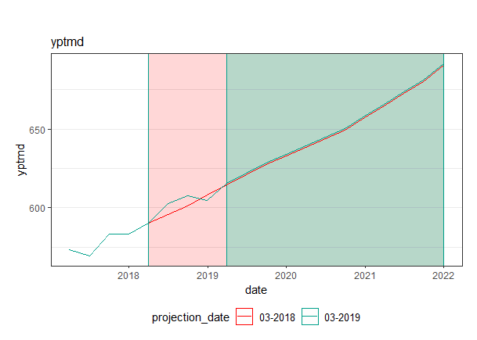

All transfers (incl health, federal, state and local)

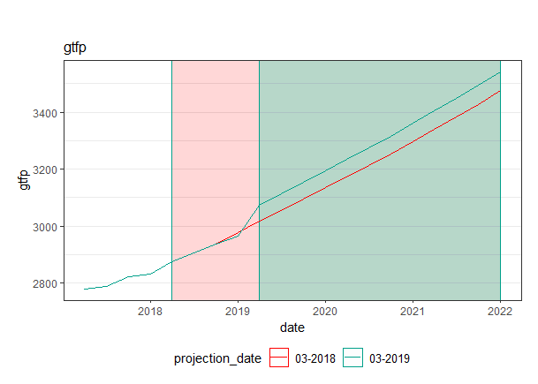

* We came up with a method to reattribute COLA-related growth to the quarter it appears in. Essentially:

1. Replicate the CBO FY levels over each of four calendar quarters
2. Create a counterfactual path for federal social benefits that grows only with the COLA rate in q1 of every year.
3. The residual between this counterfactual path and CBO’s projected path is the implied COLA adjustments. Specifically,
   1. ImpliedCOLApath(t) = ImpliedCOLApath (t-1) + COLAadjustment(t)
      1. Where ImpliedCOLApath(0) = CBO_FYprojection(0)
      2. Where COLAadjustment(t) > 0 only in Q1 of each year
   2. counterfactual(t) = CBO_FYprojection(t) – ImpliedCOLApath(t)
   3. Take the max of (a) and zero, since they won’t make downwards cola adjustments
   4. Implied Steady State path of transfers = CBO_FYprojection(t-1) - ImpliedCOLA(t)
   5. Take the 4-quarter M.A. of (c)
   6. Adjusted Transfers = (d) + (a)

Growth rates: smooths it out a tiny bit and transfers the COLA bump from q4 to q1

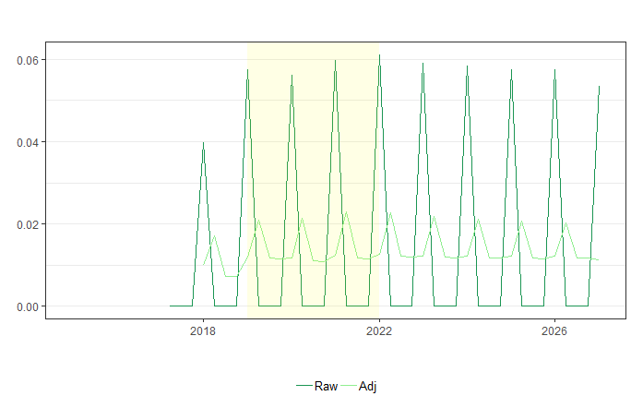

Note the levels are shifted a little lower because of the smoothing; this is ok because we’ll be attaching the path to the most recent realized level anyway

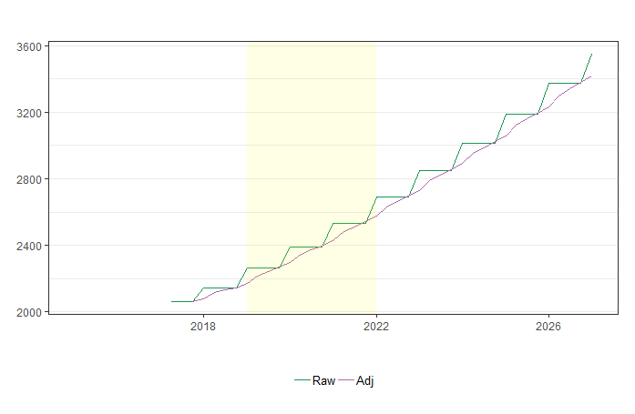

Here’s how wrong we got the **old projections** (only bar that really matters is the one with a grey line):

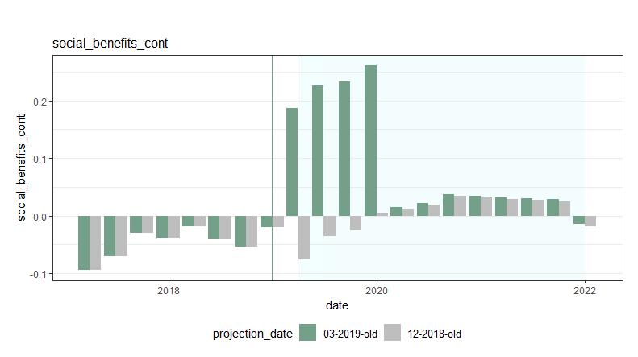

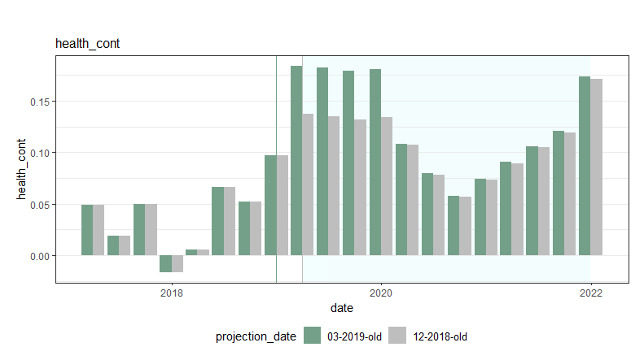

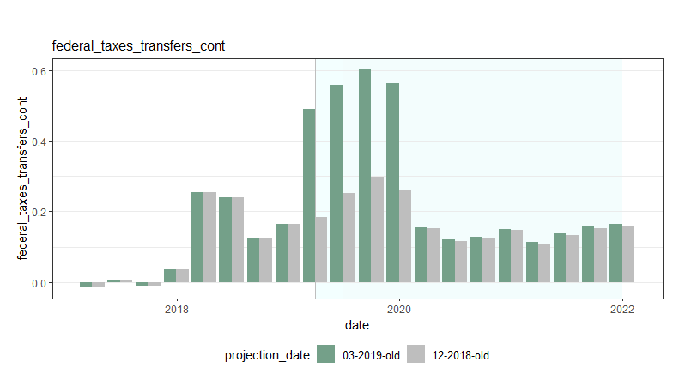

Here’s how well we performed with the new projections